SIMATS ENGINEERING
ASSESSMENT TOOL 1

COURSE NAME: COMPUTER ARCHITECTURE COURSE CODE: CSA12

COURSE OUTCOME COVERED

CO1: Analyze the functional units of a computer system including CPU, memory, bus structures, and I/O components by examining instruction execution cycles, addressing modes, and performance metrics such as CPI, clock cycles, and benchmarking (BL4)
Assessment Tool Weightage: 40%

QUESTIONS:10 Total Marks:50

ANNEXURE A
APPLICATION BASED QUESTIONS

Code of Conduct:

I N.Nesarajan/192511386 (Name / Reg No) certify that this submission is my original work and that I have adhered to the guidelines specified for this assessment.
I understand that any violation of academic integrity rules will result in disciplinary action.

Signature of the student:

ANNEXURE A
- A smart city surveillance system processes continuous video feeds from multiple cameras, where large volumes of data are transferred between I/O devices, memory, and CPU. During peak hours, the system experiences lag and delayed response in threat detection. Analyze how the interaction between CPU, memory, and I/O contributes to this issue, and explain how different bus structures (single-bus vs multi-bus) and improvements in instruction execution cycle can enhance system performance.
- A real-time stock trading application running on a processor executes millions of instructions per second, but users report delays in transaction processing during high load. The system has a high CPI due to frequent memory access and branch instructions. Examine how the fetch–decode–execute cycle impacts execution time in this scenario, and propose methods to reduce CPI and improve overall CPU performance using suitable architectural enhancements.
- An embedded system based on an 8085 microprocessor is used in an industrial temperature control unit, where sensors provide input and actuators respond accordingly. However, incorrect temperature readings are occasionally processed due to improper use of addressing modes in the program. Discuss how different addressing modes influence data access, identify possible causes of such errors, and suggest how the instruction set of 8085 can be effectively used to ensure accurate and reliable operation.
- A computing system uses an 8086 microprocessor with segmented memory for executing multiple programs simultaneously, but it encounters issues like incorrect data access and stack overflow errors. Evaluate how segmentation (code, data, and stack segments) works in 8086, analyze how improper segment handling can lead to such problems, and explain how instruction execution and addressing modes must be managed to ensure correct program execution.
- A data communication system represents packet information in hexadecimal format for ease of debugging and transmission, but a software engineer mistakenly interprets values, leading to incorrect data processing. Analyze the importance of number system conversions between hexadecimal and binary in such systems, explain how errors in conversion can affect instruction execution, and discuss how efficient CPU design and benchmarking can help detect and minimize such issues in real-time systems.
MARKS ALLOCATION
Criteria | Understanding of Problem Context (20%) | Application of Concepts (20%) | Problem-Solving Approach (20%) | Accuracy of Solution (20%) | Clarity (20%)
Q1
Q2
Q3
Q4
Q5

RUBRICS FOR CALCULATION:
Criteria | Weightage | Level 4 – Exemplary | Level 3 – Proficient | Level 2 – Developing | Level 1 – Beginning
Understanding of Problem Context | 20 | Clearly understands the problem and accurately identifies all requirements | Good understanding with minor gaps | Basic understanding; some requirements unclear | Poor understanding or misinterpretation of the problem
Application of Concepts | 30 | Accurately applies appropriate concepts to solve complex problems | Applies relevant concepts correctly with minor errors | Applies basic concepts with limited accuracy | Fails to apply appropriate concepts
Problem-Solving Approach | 20 | Logical, well-structured, and efficient approach | Mostly logical approach with minor gaps | Basic approach with some inconsistencies | Illogical or unclear approach
Accuracy of Solution | 20 | Completely correct solution with proper justification | Mostly correct with minor errors | Partially correct solution | Incorrect or incomplete solution
Clarity | 10 | Clear, well-organized, and properly explained solution | Understandable with minor clarity issues | Limited clarity and explanation | Poorly presented and difficult to understand

Question 1: Smart City Surveillance System

Identify:
The problem is caused by continuous video data transfer between I/O devices, memory, and CPU. During peak hours, the CPU becomes overloaded, memory access increases, and the bus becomes congested, leading to delays in threat detection.

Analyze:
The CPU processes instructions while memory stores video frames and I/O devices continuously send camera data. A single-bus architecture forces all components to share one communication path, creating traffic congestion. A multi-bus architecture allows simultaneous data transfers, reducing waiting time. Optimizing the instruction execution cycle by reducing unnecessary memory accesses and improving pipelining further increases system efficiency.

Evaluate:
A single-bus system is inexpensive but becomes inefficient for high-speed surveillance applications. Multi-bus architecture provides higher bandwidth, lower latency, and better CPU utilization, making it more suitable for real-time security systems.

Recommend / Design:
- Use a multi-bus architecture.
- Increase cache memory to reduce memory access delays.
- Apply DMA (Direct Memory Access) for faster I/O transfer.
- Use pipelining and parallel processing.
- Upgrade to multicore processors for simultaneous video processing.

Justify:
These improvements reduce bus contention, minimize CPU idle time, increase throughput, and enable faster threat detection, making the surveillance system more reliable.

FLOWCHART:

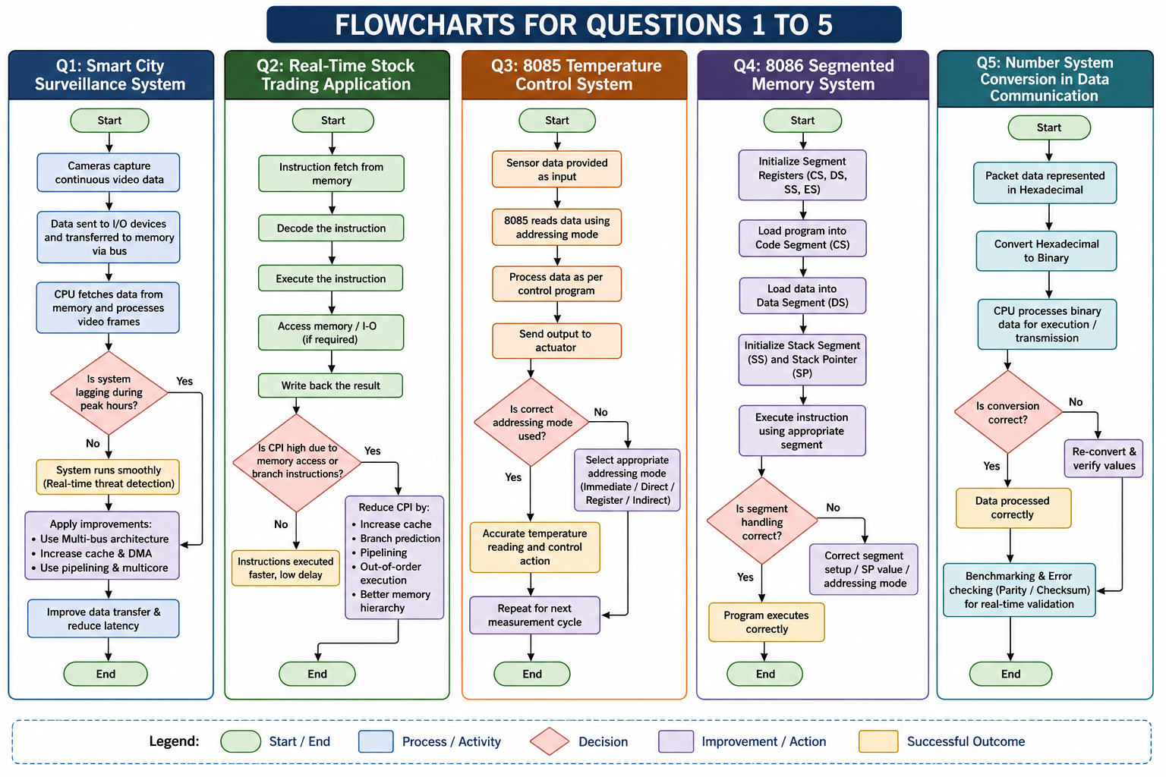
BLOCKDIAGRAM:

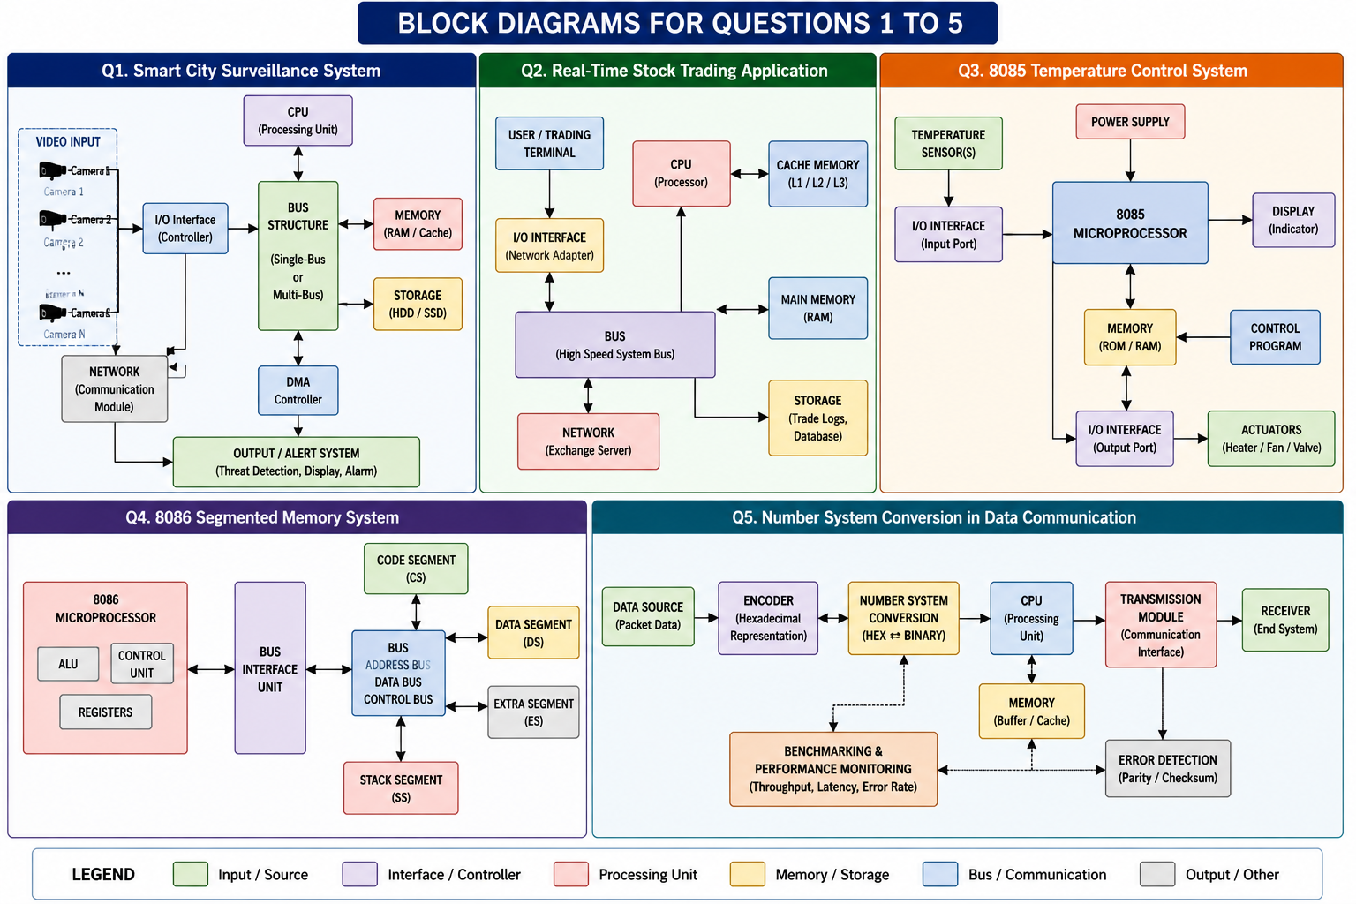

COMPARISON TABLE:


Calculation – Bus Performance
Given:
- CPU Speed = 3 GHz
- Single-Bus Transfer Time = 120 ns
- Multi-Bus Transfer Time = 60 ns
Formula
$$\text{Speed Improvement}=\frac{\text{Old Time}}{\text{New Time}}$$
Calculation
$$=\frac{120}{60}=2$$
Result:
- Multi-Bus Architecture is 2× faster than Single-Bus Architecture.
- Latency is reduced by 50%.

Solution
To improve the performance of the Smart City Surveillance System, a multi-bus architecture should be implemented instead of a single-bus architecture. The system should also use Direct Memory Access (DMA) to transfer video data directly between I/O devices and memory without involving the CPU. Increasing cache memory, implementing instruction pipelining, and using multi-core processors will further improve processing speed and reduce execution time.
Justification
A multi-bus architecture allows multiple data transfers to occur simultaneously, reducing bus congestion and improving throughput. DMA minimizes CPU workload by handling data transfers independently, while cache memory reduces memory access time. Pipelining enables multiple instructions to be executed concurrently, increasing CPU efficiency. These improvements ensure faster video processing, lower latency, and real-time threat detection, making the surveillance system more reliable and efficient.
Question 2: Real-Time Stock Trading Application

Identify
The processor experiences high CPI (Cycles Per Instruction) because of frequent memory accesses and branch instructions, causing delays in transaction processing.
Analyze

The fetch–decode–execute cycle determines the execution time of every instruction. Memory delays during instruction fetch and incorrect branch predictions increase CPI. Frequent branch instructions interrupt the instruction pipeline, reducing processor efficiency.
Evaluate
A processor with a lower CPI completes more instructions in less time, improving application performance. High CPI reduces throughput and affects user response time during heavy workloads.

Recommend / Design
- Increase cache memory size.
- Use branch prediction techniques.
- Implement instruction pipelining.
- Apply out-of-order execution.
- Improve memory hierarchy using faster RAM and cache.

Justify
Reducing CPI improves CPU utilization, decreases execution time, and enables the trading system to process more transactions accurately under high load.

FLOWCHART:


BLOCK DIAGRAM:



COMPARISON TABLE:



Calculation – CPU Execution Time
Given:
- Instruction Count (IC) = 2 × 10⁶
- CPI = 4
- Clock Rate = 2 GHz
Formula
$$Execution Time=\frac{IC×CPI}{Clock Rate}$$
Calculation
$$=\frac{2×{10}^{6}×4}{2×{10}^{9}} \\ =\frac{8×{10}^{6}}{2×{10}^{9}} \\ =0.004 sec \\ =4 ms$$
After Optimization
Suppose CPI becomes 2
$$=\frac{2×{10}^{6}×2}{2×{10}^{9}} \\ =0.002 sec \\ =2 ms$$
Result
Execution Time reduced from
4 ms → 2 ms
Performance Improvement
$$=\frac{4}{2}=2$$
CPU performance improves by 2×

Solution
The processor performance can be improved by reducing the Cycles Per Instruction (CPI) through the use of instruction pipelining, branch prediction, and a larger cache memory. Faster memory hierarchy and optimized instruction scheduling should also be implemented to minimize execution delays.
Justification
Lowering CPI decreases the total execution time of programs, allowing the processor to complete more instructions within the same clock cycles. Branch prediction minimizes pipeline stalls, while cache memory reduces memory access delays. As a result, the stock trading application processes transactions more quickly, improves response time, and maintains high performance during heavy trading periods.

Question 3: 8085 Temperature Control System

Identify
Incorrect temperature readings occur because improper addressing modes access the wrong memory locations, resulting in incorrect sensor values being processed.

Analyze
The 8085 microprocessor supports immediate, direct, register, indirect, and implied addressing modes. Choosing an incorrect addressing mode causes invalid data retrieval or incorrect instruction execution, affecting sensor accuracy.

Evaluate
Proper addressing modes improve data accuracy, reduce execution errors, and increase system reliability. Incorrect addressing modes may generate wrong outputs and unsafe industrial operation.

Recommend / Design
- Use direct addressing for fixed sensor locations.
- Use register indirect addressing for dynamic memory access.
- Validate sensor inputs before processing.
- Implement error-checking routines.
- Optimize instruction sequences.

Justify
Correct addressing ensures accurate data access, improves temperature measurement reliability, and prevents incorrect actuator responses.

FLOWCHART:



BLOCK DIAGRAM:



COMPARISON TABLE:



Address Calculation
Suppose
Sensor Data Location
Memory Address = 2500H
Instruction
LDA 2500H
CPU reads data directly from
2500H → Accumulator
Suppose
Temperature Value
3CH(Hex)
Convert to Decimal
$$3C_{16} \\ =(3×16)+(12) \\ =48+12 \\ ={60}^{∘}C$$
Result
Correct Addressing Mode gives
Temperature = 60°C
Wrong addressing mode may fetch another location such as 2600H, producing incorrect readings.

Solution
The 8085-based temperature control system should use the correct addressing mode for accessing sensor data. Direct addressing should be used for fixed memory locations, while register indirect addressing can be used for dynamic data access. Error-checking routines should also be added to validate sensor readings before processing.
Justification
Using the correct addressing mode ensures that the processor retrieves data from the intended memory location, preventing incorrect temperature readings. Error validation increases the accuracy and reliability of the system. These improvements enable the controller to monitor temperature correctly and respond safely to changes in industrial environments.

Question 4: 8086 Segmented Memory System
Identify
The system experiences incorrect data access and stack overflow due to improper management of code, data, and stack segments in the 8086 microprocessor.
Analyze
The 8086 divides memory into Code Segment (CS), Data Segment (DS), Stack Segment (SS), and Extra Segment (ES). Incorrect segment register values or stack pointer updates lead to invalid memory access and program execution errors.
Evaluate
Proper segmentation improves memory organization, multitasking capability, and program execution. Improper segment handling reduces system reliability and increases runtime errors.
Recommend / Design
- Initialize segment registers correctly.
- Monitor stack pointer values.
- Use appropriate addressing modes.
- Separate program, data, and stack memory.
- Perform memory validation before execution.
Justify
Correct segmentation ensures safe memory access, prevents stack overflow, and supports reliable multitasking in 8086 systems.
FLOWCHART:



BLOCK DIAGRAM:



COMPARISON TABLE:



Physical Address Calculation
Formula
$$Physical Address=(Segment×16)+Offset$$
Suppose
CS = 2000H
IP = 1500H
Calculation
2000H × 10H = 20000H
Now add Offset
20000H
+1500H
-------
21500H
Result
Physical Address
21500H
Correct segment values ensure correct instruction execution.

Solution
The 8086 microprocessor should properly initialize the Code Segment (CS), Data Segment (DS), Stack Segment (SS), and Extra Segment (ES) registers. The stack pointer should be monitored regularly, and memory segments should be organized separately to avoid conflicts and stack overflow.
Justification
Proper memory segmentation allows the processor to access instructions, data, and stack memory correctly. Correct initialization of segment registers prevents invalid memory access and program crashes. Efficient stack management also avoids stack overflow, improving the stability and reliability of the embedded system.

Question 5: Number System Conversion in Data Communication

Identify
The engineer incorrectly converts hexadecimal values into binary, causing packet information to be misinterpreted and resulting in incorrect data processing.

Analyze
Computers internally process data in binary, while hexadecimal provides a compact representation. Incorrect conversion changes instruction operands and packet contents, leading to execution errors and communication failures.

Evaluate
Accurate number system conversion improves debugging, ensures reliable communication, and prevents instruction execution errors. Efficient CPU design and benchmarking help detect such issues quickly.

Recommend / Design
- Use automated conversion tools.
- Verify binary and hexadecimal values before execution.
- Apply benchmarking techniques to monitor performance.
- Implement error detection methods such as parity and checksum.
- Optimize CPU architecture for faster validation.

Justify
Correct number conversion ensures accurate packet transmission, reliable instruction execution, improved debugging, and enhanced overall system performance.

FLOWCHART:



BLOCK DIAGRAM:



COMPARISON TABLE:



Q5. Number System Conversion
Hexadecimal to Binary Calculation
Given
Hex = 4A
Convert each digit
4 = 0100
A = 1010
Binary
4A(H)

↓

01001010(B)
Verification
Decimal
4A(H)

=(4×16)+10

=64+10

=74
Binary Verification
01001010₂

=64+8+2

=74
Hence
4A(H)=01001010(B)=74₁₀

Solution
The engineer should verify all hexadecimal-to-binary conversions before processing data packets. Automated conversion tools, parity checking, checksum verification, and benchmarking techniques should be used to detect conversion errors and improve CPU performance.
Justification
Accurate number system conversion ensures that binary data is interpreted correctly by the processor, preventing communication errors and incorrect instruction execution. Error detection techniques improve data integrity, while benchmarking helps evaluate processor performance. These methods ensure reliable communication, accurate packet processing, and efficient overall system performance.

